HMIS Training Manual

Etosite: tchc.etosoftware.com
Username: is email
Password:_______________

Enrolling Participants: There are two ways to enroll a participant to a program.
- Find and Enroll Participants across the Enterprise
- If you do not find the Participants across the Enterprise then click on Add New Family

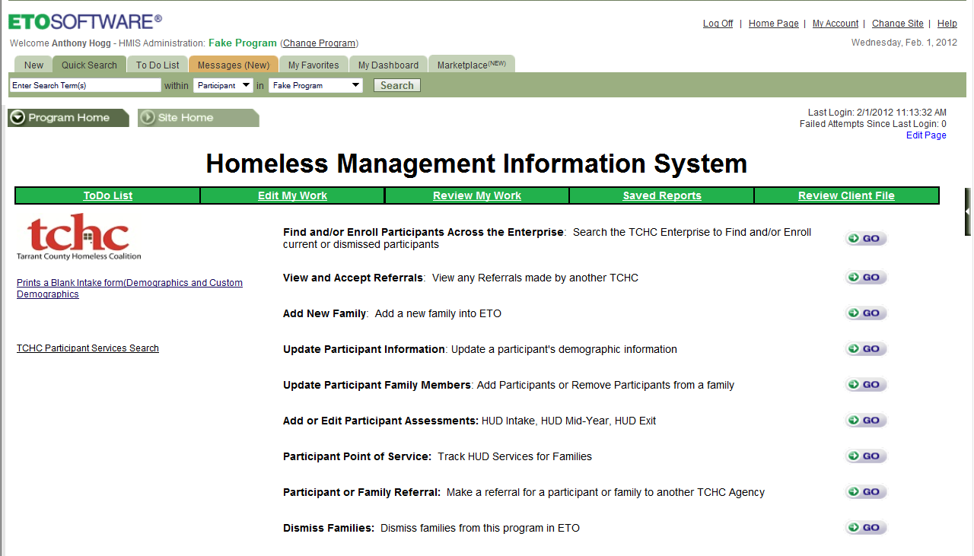
Click on the GO next to Find and Enroll Participants Across the Enterprise
Search by adding the Last Name, First Name, SSN or Family Name.

If you find the participant you are looking for check the box next to the participant’s name. Then select the Enroll Same Date.
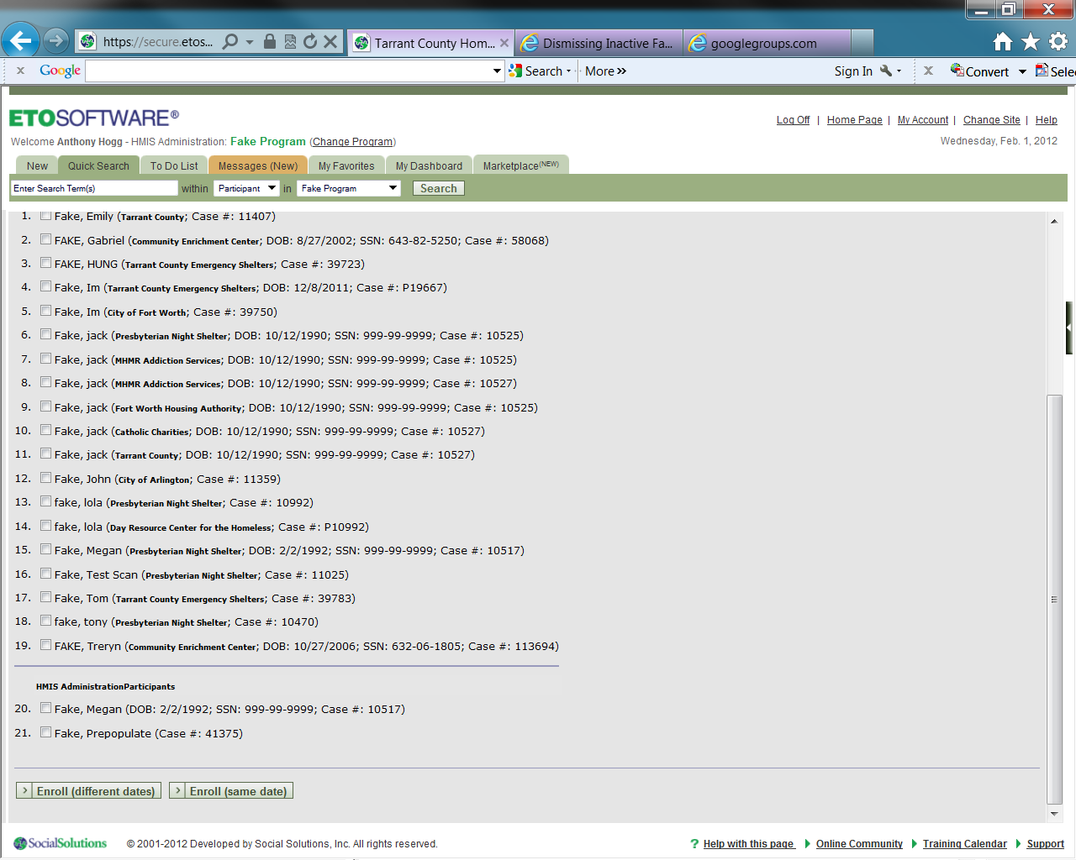
Enroll with the Same Start Date. Select the right date and the click the Add New Participants.

Add New Family: select the Click to Add household/Family Member by Family Relationship.

Yellow fields are required. If you need to add multiple members to a family click on the Click to Add Household/Family Member by Family Relationship. Once finished added all participants to a household make sure you add the right start date and then select save.
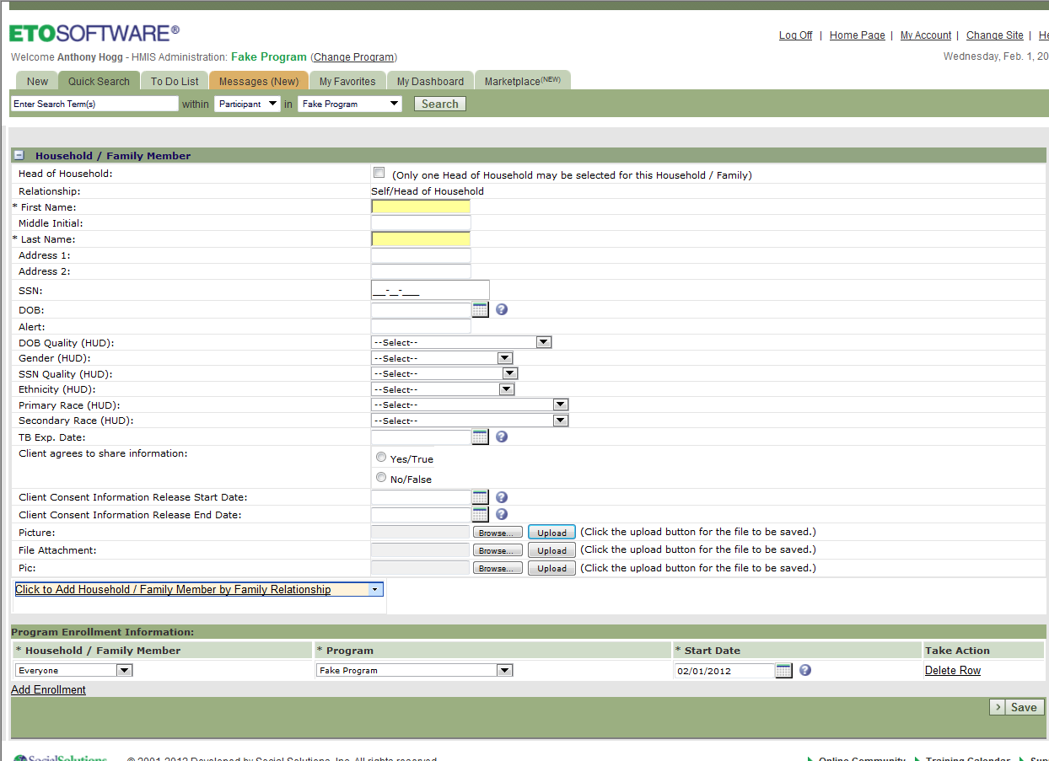

Using MY Dashboard for adding Assessments, Points of Services, referrals and Dismissing Clients: Select the My Dashboard
Tab.

There are two dashboards one for the Case Manager and one for the client. The Case Manager dashboard shows your recent efforts, assessments, and participants. To add an assessments or effort to a participant you need to go to the Clients Dashboard by selecting Dashboard Search or by the Recent Participants.
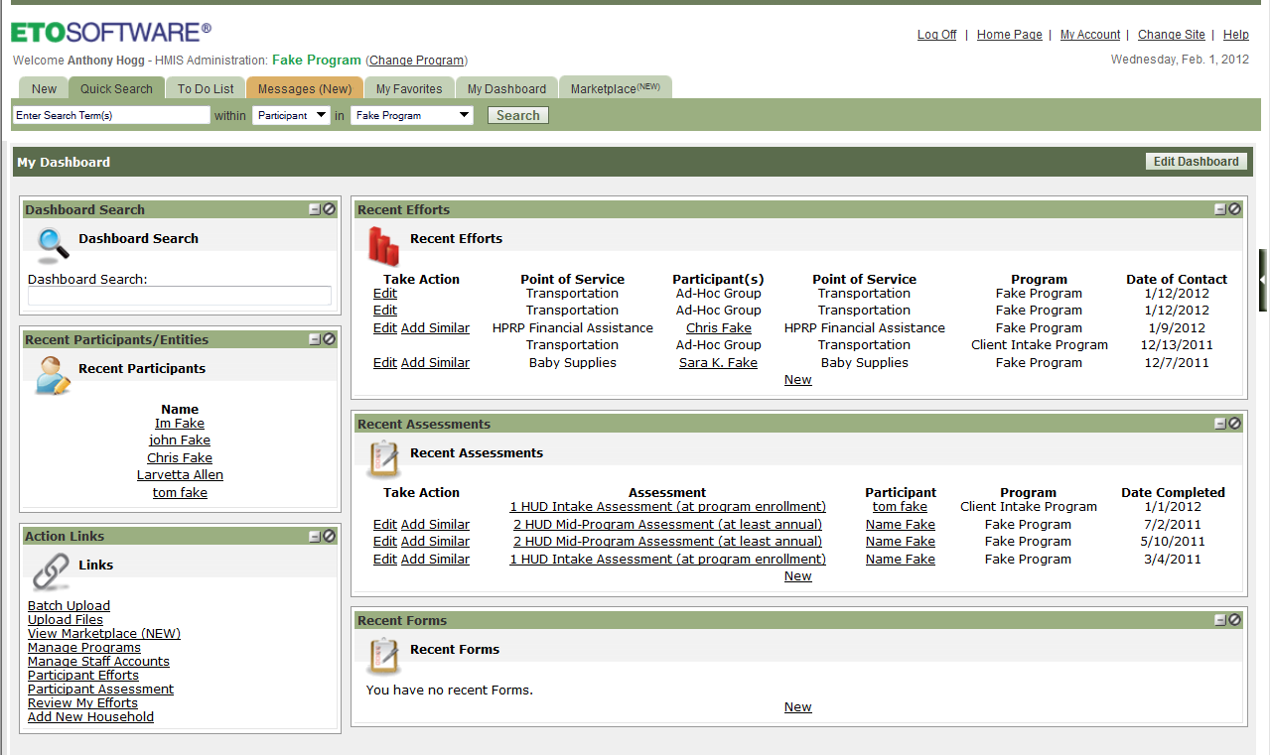

Participants Dashboards
When working with clients you can add Assessments, Efforts, Referrals, edit their Demographics and even Dismiss them from their dashboard. Just click on the new tab or the action links.

