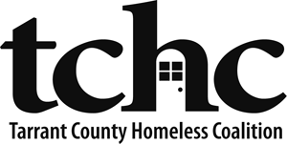

TCHC CoC HMIS ETO Participating Agencies

TCHC CoC HMIS System “ETO” ⎪ tchc.etosoftware.com

The following Participating Agencies are a part of the official TCHC CoC HMIS ETO System and have agreed through a signed End User Agreement to uphold relevant Federal and State confidentiality regulations and laws that protect Client records.

- ACH Child and Family Services
- Aids Outreach Center
- Arlington Housing Authority
- Arlington Life Shelter
- Catholic Charities
- Center of Hope
- City of Arlington
- City of Fort Worth
- Cornerstone Assistance Network
- Community Enrichment Center
- Day Resource Center for the Homeless
- JPS Health Network
- First Street Methodist Mission
- Fort Worth Housing Authority
- GRACE
- Helping Restore Ability
- MedStar EMS
- MHMR Addiction Services
- MHMR Homeless Services
- Presbyterian Night Shelter
- Recovery Resource Council
- SafeHaven of Tarrant County
- The Salvation Army Arlington Corps
- The Salvation Army Mabee Center
- Tarrant County
- Tarrant County Homeless Coalition
- Tarrant County Samaritan Housing
- Texas ReEntry Services
- UNT Health Science Center/TCOM
- University of Texas at Arlington
- Veteran's Administration
- Volunteers of America
- Women’s Center of Tarrant County
- Workforce Solutions for Tarrant County
- YWCA of Fort Worth & Tarrant County

