Tip Sheet: Rapid Rehousing Start Dates
Each year, HUD provides guidance for CoCs, HMIS Lead Agencies, and HMIS users to help them understand the data elements that are required to meet participation and reporting requirements established by HUD and other federal partners. In 2017, the data element Project Entry Date changed to Project Start Date to capture more complete information about persons accepted into and residing in all types of Permanent Housing. Paired with the Housing Move-In Date, it becomes possible to determine the length of time from project start to housing placement for all PH clients.
What does this mean?
The Rapid Rehousing Project Start Date is the date the client becomes eligible for the program, even if this date is only in the initial engagement stage. The criteria that must be met prior to project start are as follows:
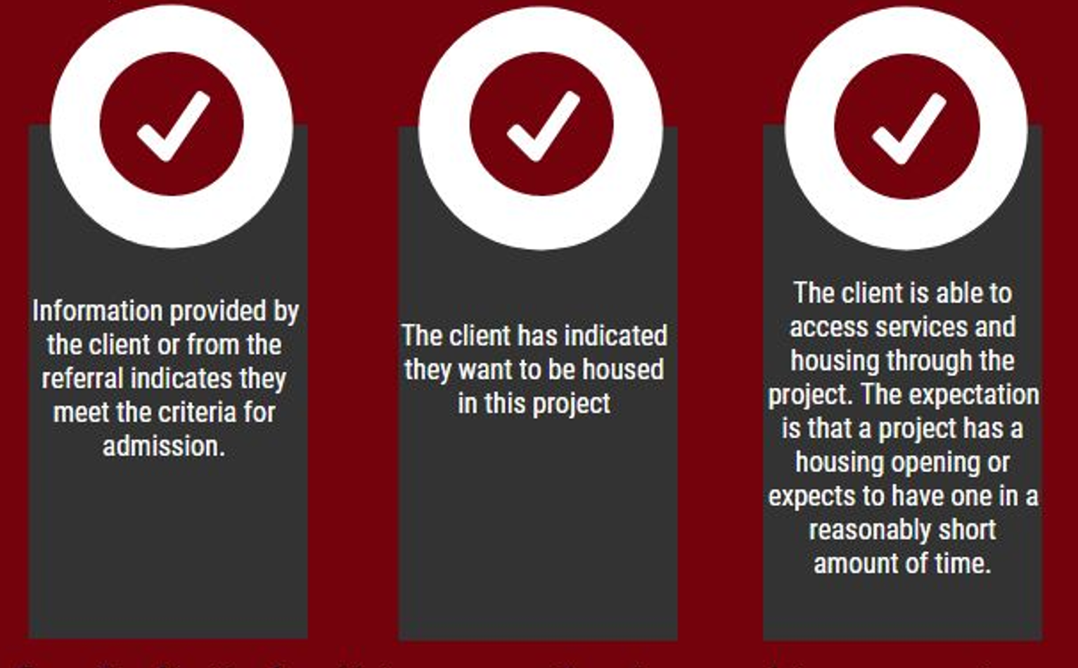
Knowledge into Practice
Susie has been placed on the Rapid Rehousing Homebase report and is next in line. The housing navigator working with Susie is informed of availability in the ABC Rapid Rehousing Program at XYZ Organization. The Homebase report indicates that Susie meets all requirements for the program so the RRH case manager contacts Susie who agrees to be part of the program on July 20, 2017. The case manager then conducts a HUD entry assessment with a Project Start Date of July 20, 2017. The case manager continues to work with Susie who moved into an apartment on August 13, 2017. An update assessment is then conducted with a residential move-in date of August 13, 2017.

