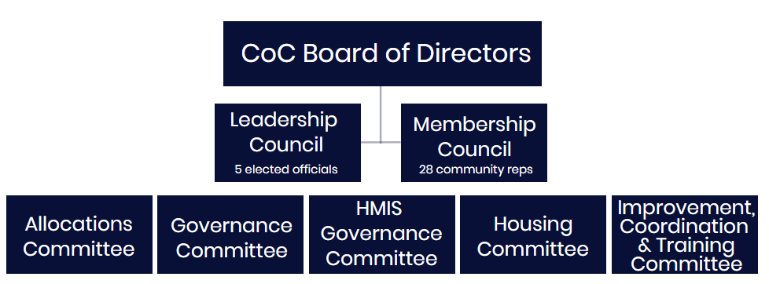

Committee Purpose and Alignment
Allocations
Purpose: The Allocations Committee conducts the CoC Program Grant and State ESG project prioritization and prepares allocation recommendations. Committee members cannot currently receive funding and must not have submitted an application for funding.
Strategic Plan Alignment: Goal 5: Committed Resources
Governance
Purpose: The Governance Committee conducts the annual nominations process for the CoC Board of Directors and oversees community engagement efforts. Committee members must include three members of the Leadership Council and three members of the Membership Council.
Strategic Plan Alignment: Goal 4: Engaged Community

HMIS Governance Committee
Purpose: The HMIS Governance Committee oversees the Homeless Information Systems Management, including planning, participation, selection, implementation and ongoing oversight of systems such as ETO, Green River and Outreach Grid.
Strategic Plan Alignment: Goal 2: Data Driven Solutions

Housing Committee
Purpose: The Housing Committee makes recommendations to the CoC Board on the planning, CoC wide policies, procedures, implementation and oversight needed to ensure adequate housing stock and access for those at risk of or experiencing homelessness.
Strategic Plan Alignment: Goal 3: Housing Focused

Improvement, Coordination & Training Committee
Purpose: The ICT Committee oversees the development and implementation of CoC-wide policies, processes and training and oversees all provider workgroups and special population ad hoc subcommittees.
Strategic Plan Alignment: Goal: 1: Effective Response System

