Schedule

Quarterly First Tuesday at 10:00 AM

|  |  |
| --- | --- |
| *Last* | *Next* |
| October 1, 2020  Virtual | February 2, 2021  Virtual |

## Report

The Allocations Committee met in October to review the proposed structure of the Committee, including changes to the Performance and Ranking Workgroups. The Committee is in a transition as it moves to the new structure and all groups are repopulated to align with strategic goals. The Allocations Committee will resume meeting with this new structure with its first meeting on February 2, 2021.

The Homeless Coalition received an allocation of $3,537,894 on behalf of our local CoC and has now completed a local competition for these funds. In Round II, these funds were restricted to homeless prevention, rapid rehousing and landlord engagement. Additionally, applicants were restricted to currently CoC funded agencies and had a minimum request amount of $500,000. Due to the Allocations Committee being in transition, the Executive Committee approved recommended allocations, followed by both the Membership and Leadership Councils of the CoC Board. The Homeless Coalition submitted funding allocations to TDHCA on 11/21/2020.

Performance Workgroup invited all CoC-funded entities to its December meeting on December 15 to review proposed changes to the CoC NOFA scorecard for the 2021 NOFA. All agencies had an opportunity to provide feedback on the scorecard and general consensus was reached on: the utilization rate points, projected project spend down calculation, cost efficiency calculation, an auto-renewal for projects less than 2 years old, and the ranking committee considering geography and special populations in comparing projects.

## Key Takeaways

The Allocations Committee will begin its new structure to broaden its focus to fully meet Strategic Plan Goal 5. The Allocations Committee will evaluate system needs, align community resources to prevent and respond to homelessness, and evaluate the community’s performance in preventing and responding to homelessness. Structure attached.

The CoC is reviewing changes to the NOFA scorecard based on agency feedback.

## Recommendations to CoC Board

None at this time; ESG competition approvals completed via email.

**Allocations Committee Proposed Reformatting**

**Purpose:** Allocation Committee’s purpose is to align needs with resources, increase system dollars and improve performance across the continuum. Improving performance across the continuum includes prevention of homelessness and diversion all the way to emergency shelter and homeless response programs.

**Purpose:** Evaluate system needs, align community resources to prevent and reduce homelessness, evaluate the performance of the community in preventing and responding to homelessness. Community resources to be aligned to prevent and reduce homelessness include: CoC Funding, ESG, CDBG, CSBG, HOMES, HOPWA, CARES, EFSP, Directions Home, and new private and public funding. Approves policy and scoring criteria for NOFA.

**Membership:** Representation from local governments and housing authorities, VA, United Way and other funders.

**Meets Quarterly**

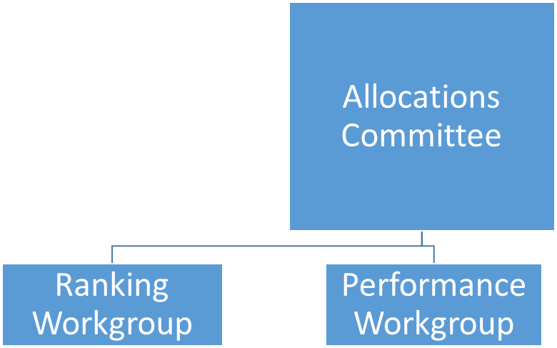

**Purpose:** Rank Score Cards for annual HUD NOFA and as needed for other local competitions.

**Membership:** Representatives from organizations not receiving CoC funding.

**Meets** as needed June through September or during the annual NOFA competition.

**Purpose:** Develops ranking and scoring policy, evaluates score card for annual NOFA and makes recommendations on these to Allocations Committee.

**Membership:** Representatives from stakeholder organization.

**Meets** quarterly with most work occurring January-March.