- Navigate to the home screen:

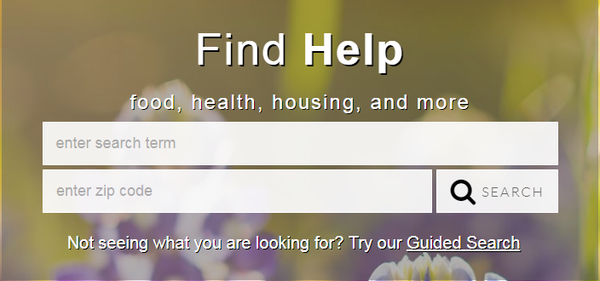

- Begin the search by typing in a term. A drop-down box will appear with terms that may match what service is needed:

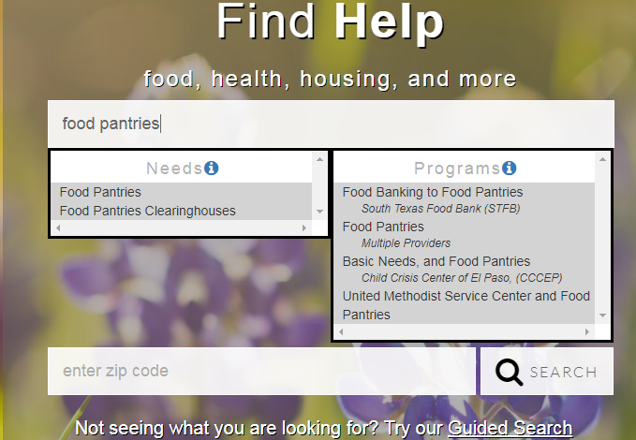
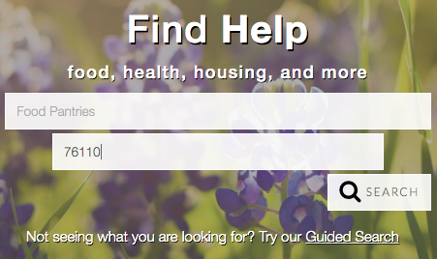
- Enter a zip code and select search:

Search results will appear based on the person’s proximity to the service:(NOTE: the Map tool sometimes does not work or you may need to zoom out.)

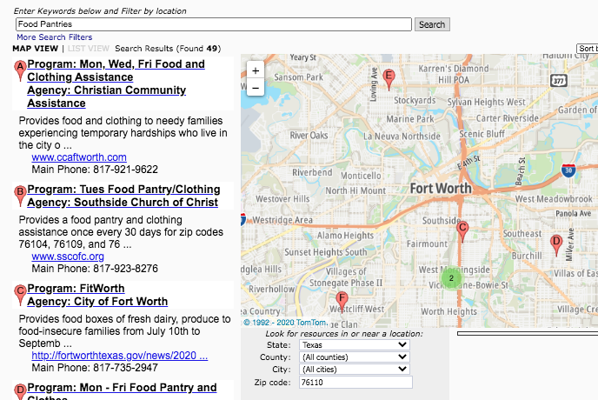

4. Click into the program to see the details of the service The details will appear in a new window, so pop-ups need to be enabled for this site.

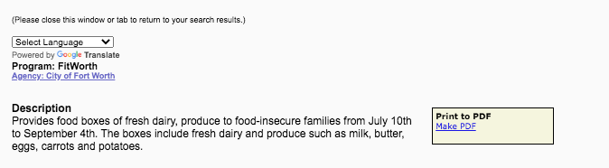

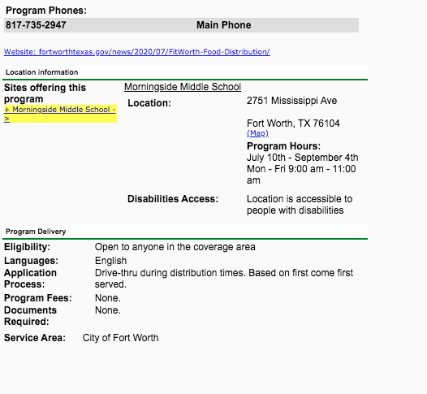

- Pay close attention to the Service Area to make sure that the person can access the service. The database should pull information for the program that serves the person’s zip code; however, it is always best to check.

- It is possible to create a PDF file of the service for easy printing or emailing of service referrals (see box circled above). A sample of the PDF is included at the end of this document.

The record contains all information that the agency has provided 2-1-1 regarding how to access the services.

It is also possible to search an agency’s additional services listed in 211. Simply scroll to the bottom of the agency’s page, click the program name (listed in blue) that you want more information on.

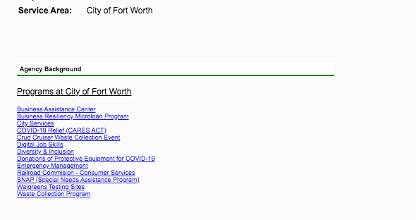

- The Guided Search feature is another way to locate services when the search term is not known or isn’t producing results for the client.

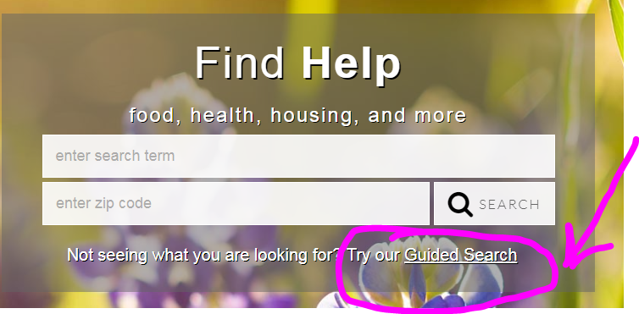

When you click on “Guided Search”, the screen will look like this:

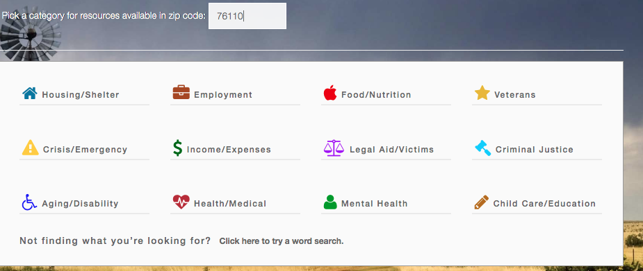
The zip code still needs to be entered to produce results accurate for the client’s situation.

In this example, Housing/Shelter is selected for the initial search:

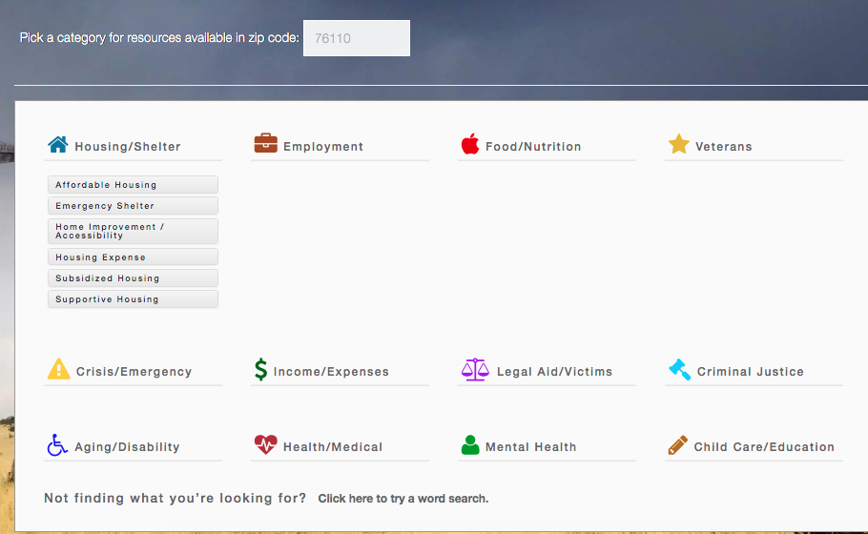

Select a category that is most applicable to the client’s need. In this case, the search selected is Housing Expense:

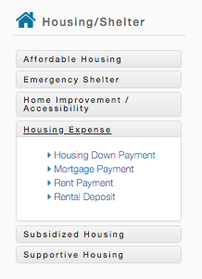
Selecting Rent Payment provides 24 results (when searching on zip code 76110). It is now possible to select the service the may be most appropriate to the client and review the program detail page. There may be several and this provides the client the ability to choose the program that fits their particular needs.
Notice that in the search bar the term Rent Payment is changed to Rent Payment Assistance. This change is because the search term in the database is actually Rent Payment Assistance and it has Rent Payment as one of its keywords tags.

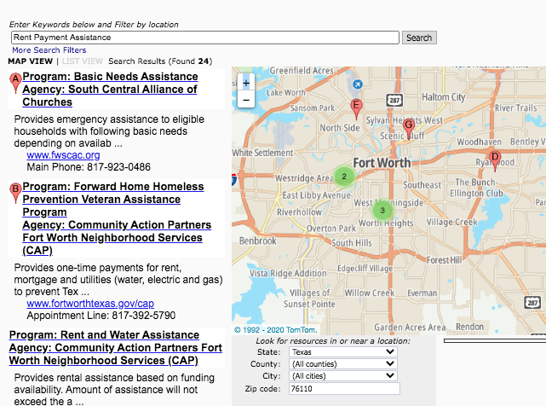

Final Note: Resrouces are now being reviewed and updated as needed or at a miniumum, every 6 months However, we encourage any feedback that information may need to be updated. In addition, new programs are added and programs no longer with funds are inactivated. Please check the database as needed and do not rely soley on what was in the database yesterday.

We prefer to have emails if you notice anything incorrect, but either email or submitting on-line will get to us.
Dianne Long, Manager dlong@unitedwayhouston.org
Cleia Dominguez, Lead Resource Specialist cdominguez@unitedwayhouston.org
Alexa Kelly, Resource Specialist akelly@unitedwayhouston.org
Sarah O’Connel, Resource Specialist soconnell@unitedwayhouston.org
Karla Flores, Resource Specialist kflores@unitedwayhouston.org
Heidi Tso, Resource Specialist htso@unitedwayhouston.org

