The Homeless Coalition
Training Policies and
Procedures

Table of Contents

- Overview 3
II. Members vs. Non-Members …………………………………………………………………………………………………………3
III. Training Registration .………………………………………………………………………………………………………………….3
  - Members 3
  - Non-Members .………………………..……………………………………………………………………………………………4
  - Cancellation Fees 5
IV. Training Attendance 6
V. Training Participation 7
VI. Training Invoices 7
VII. Certificates of Completion & CEUs……………………………………………………………………………………………… 8

I. Overview

Regular ongoing training is essential to staying current on best practices and has enabled our community to continue to perform well at both the local and national levels. The Homeless Coalition wants to ensure that we are maximizing all resources available to the Continuum of Care (CoC), including training and professional development resources. The Training Policies and Procedures Manual was created to provide a written reference and ensure that training policies and procedures are transparent, administered uniformly, and easily accessible for all partners.

Training provided by the Homeless Coalition Training Department is advertised via the Training Newsletter and on the Community Events Calendar on the Homeless Coalition website. All training provided by the Homeless Coalition requires registration prior to the scheduled training. Anyone who shows up for a Homeless Coalition training without prior registration will not be permitted to attend the training. Individuals interested in attending Homeless Coalition training can register for any and all training opportunities directly from the Training Newsletter or the Community Events Calendar. Contact Audrey Klein if you are interested in receiving the Homeless Coalition Training Newsletter.

II. Members vs. Non-members

Members are individuals who are employed at a CoC Member Organization that serves in the TX-601 geographical area of Tarrant and Parker counties or individuals who are Homeless Coalition Members. As a condition of membership, Members can register and attend all Homeless Coalition-sponsored training free of charge.

Non-members: “Non-members” are individuals who are not employed at a CoC Member Organization nor a member of the Homeless Coalition. Please note that non-members will be responsible for paying training registration fees to attend any Homeless Coalition training.

Interested in becoming a member? Click here for more information.

III. Training Registration

A. Members

All CoC members (those employed at a partner agency) must register for all Homeless Coalition training using their agency email address. This information will be used to contact and inform registrants of training updates, reminders, cancellations, and fees. If a CoC member registers for a Homeless Coalition training using their personal email, Homeless Coalition staff will attempt to contact the CoC member to update email information and confirm membership status. If Homeless Coalition staff is unable to make

contact, the registration will be canceled, and the registrant will not be permitted to attend the training.

Homeless Coalition Members can register for all Homeless Coalition training using either their personal or work email. Training department staff will confirm membership status.

Member training registration tips:
- Individuals employed at a CoC Member Organization must register for all training using their work email.
- When asked “Are you affiliated with TX-601?” select:
  - Yes, I am affiliated with TX-601.
- When asked “Are you a Homeless Coalition Member?” select:
  - No (unless you have made an individual contribution to the Homeless Coalition to become a Coalition Member).
- When members register for Homeless Coalition training, you will see a general admission price and payment instructions before registration is complete. Please disregard the price and payment instructions as members can attend training free of charge. View the image below as an example.

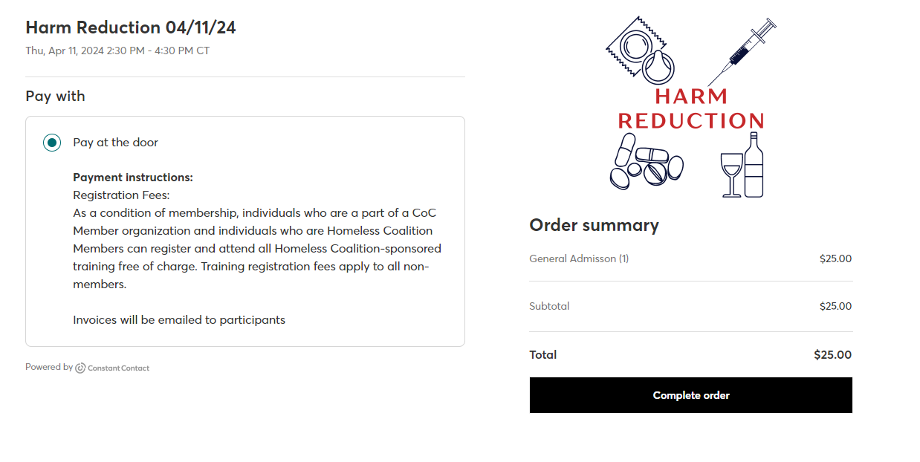
B. Non-Members

Training registration fees apply to all non-members. Training registration fees for non-members are based on the total number of training hours. Registration fees will be billed to all non-members following the registration process using the email provided during registration. Registrants will be informed that if they do not pay the registration fee, their registration will be canceled, and they will be prohibited from attending the training. If a non-member arrives at a training session without paying a registration fee, they
will not be permitted to stay unless they are prepared to pay the registration fee at the door. If a non-member prefers to pay at the door, this must be communicated and be approved by Homeless Coalition staff before the training session. Review the chart below for training registration fees.

Training Hours | Membership Status | Training Registration Fee | Cancellation Fee  (without 24-hr notice)
1-2 | Members | $0 | $25
 | Non-Members | $25 | Cost of Registration
3-4 | Members | $0 | $50
 | Non-Members | $50 | Cost of Registration
4-5 | Members | $0 | $75
 | Non-Members | $75 | Cost of Registration
5+ hours | Members | $0 | $100
 | Non-Members | $100 | Cost of Registration
*Registration fees are nonrefundable

Non-member training registration tips:
- Please register for all training using your work email or personal email.
- When asked “Are you affiliated with TX-601?” select:
  - No, I am not affiliated with TX-601.
- When asked “Are you a Homeless Coalition Member?” select:
  - No
- When registering for Homeless Coalition training, all non-members will see a general admission price and be asked to pay at the door before registration is complete. All non-members will be invoiced via PayPal for all training registration fees. Non-members will not be permitted to attend any training until registration fees are paid in full.

C. Cancelation Fees

Members: Any member who provides at least a 24-hour notice of cancelation will not receive any additional cancelation fees. Any member who does not provide at least a 24-hour notice of cancelation will be charged the training registration fee.

Non-members: Any non-member who provides at least a 24-hour notice of cancelation will not receive any additional cancelation fees. Instead, the registration fee can be used as credit for future Homeless Coalition training and all registration fees are non-refundable.

Any non-member who does not provide at least a 24-hour notice of cancelation will automatically forfeit the training registration fee.

To help remind registrants of upcoming trainings, Homeless Coalition training staff will send 3 separate training notification emails:

- Confirmation email – Sent to registrants immediately after training registration is complete.
- Reminder email #1 – Sent to registrants 1 week before the scheduled training date.
- Reminder email #2 – Sent to registrants the morning of or the day before the training (dependent on training time).

All registrants can cancel a training registration by:

- Completing the Training Cancellation Form (preferred method).
- Click the “Unable to attend” link on training reminders sent out prior to the scheduled training.

IV. Training Attendance
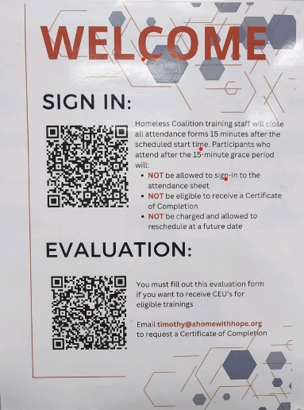
Participants are expected to arrive at all training sessions on time. Once participants arrive at any in-person training session, they must locate the “Sign In” poster placed in the room to record training attendance. When attending online or webinar training, participants will be sent a link to record attendance. Participants will be required to submit their name, agency, and email at EVERY training they attend to verify attendance and ensure accurate attendance records. View the image to the right for an example of the sign in poster.

Once participants submit attendance information, they will get an automatic reply saying their response was submitted. If a participant does not receive a response, then the sign-in process was not completed successfully. If staff fail to sign in for training, no training credit or certificate of completion will be awarded.

Participants will be given a 15-minute grace period after the scheduled training start time for late arrivals. Participants who arrive after the 15-minute grace period will NOT be eligible to receive a Certificate of Completion. If participants choose not to remain at the training due to late arrival, they have the option to reschedule for a future training date without any fees or penalties. Participants should get with Homeless Coalition staff to communicate this before leaving the training or they run the risk of being marked as not attended and accruing missed training fees.

V. Training Participation

Participant expectations during training sessions are as follows:

- Arrive (physically or virtually) before the scheduled start time to ensure that the training can start on time.

- Be present and engaged. Take part in the full duration of the training session and participate in at least 85% of the training.

- Silence cell phones, refrain from texting, and refrain from using computers, phones, and other electronic devices during the training session unless otherwise directed to do so by the trainer.

- Be respectful of the trainer and other participants. Any behavior or views expressed that are seen as discriminatory or derogatory will not be tolerated and the participant will be asked to leave the training session.

Please note: Any serious breach of the above expectations may be communicated to the participant’s employer.

VI. Training Invoice Billing

Members: A training invoice will be sent to individuals who have accrued training fees due to not attending a training session they previously registered for or not providing at least a 24-hour notice of cancelation. The invoice will include a detailed list of the missed training name(s), date(s), the individual responsible for payment, and total amount due to the Homeless Coalition.

Please note: Any member with an outstanding balance is liable to have access to TalentLMS, HMIS, CAS and/or the Data Warehouse revoked until the balance is paid in full.

Non-members: PRIOR to the scheduled training date, all non-members will be invoiced a training registration fee, using the email provided on the training registration form. This invoice will include the training name, date, and total amount due to the Homeless Coalition. Non-members will not be permitted to attend any Homeless Coalition training without paying the registration fee in full.

Training registrations will be immediately canceled for any registrant (member or non-member) who has an outstanding training balance. Training balances must be paid in full before registrants are allowed to attend any additional training sponsored by the Homeless Coalition.

VII. Certificates of Completion/CEUs

Participants who attend the full length of a training session are eligible to receive a Certificate of Completion or CEUs (if applicable). Participants must complete a training evaluation for the training they attended to receive a Certificate of Completion or CEUs. The QR code for training evaluations can be found on the training sign in poster. Homeless Coalition staff will review all completed training evaluations and send Certificates of Completion or CEUs to participants who completed the evaluation.

Please feel free to contact Shannon Barnes if you have any additional questions or concerns.

